Moreno, Melissa

April 1, 2019

SUR5386

Tutorial 6- Unsupervised Classification

3.i

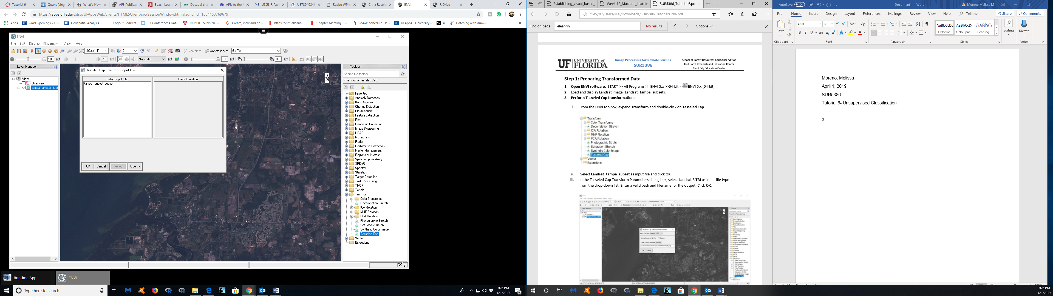

3.ii

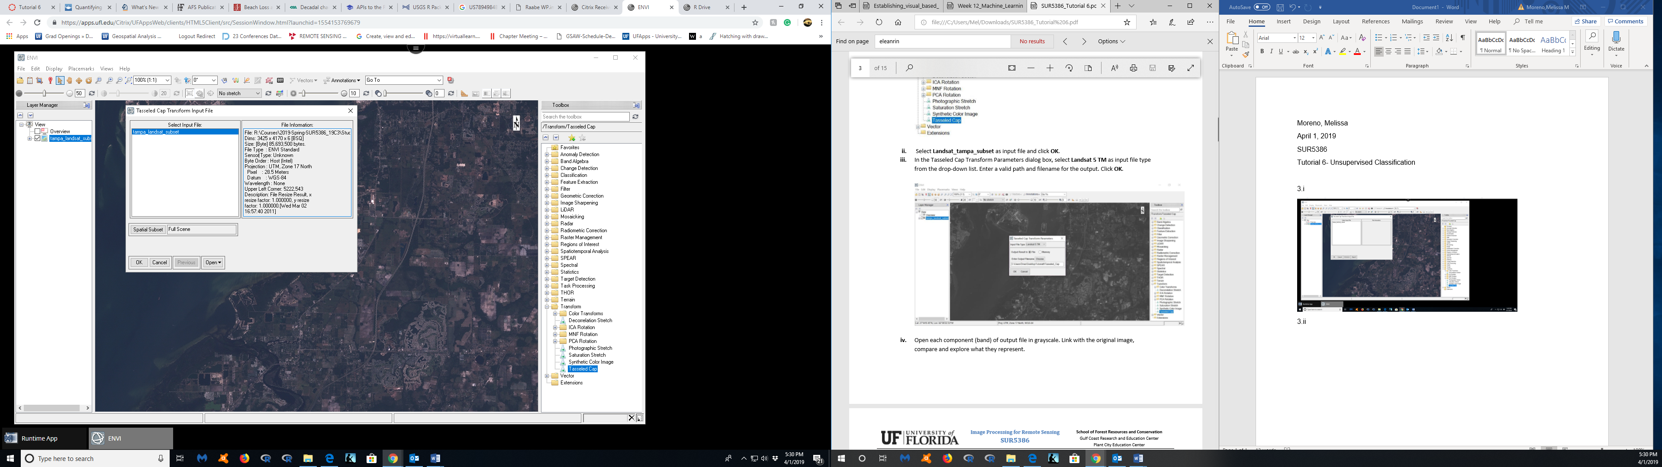

3.iii

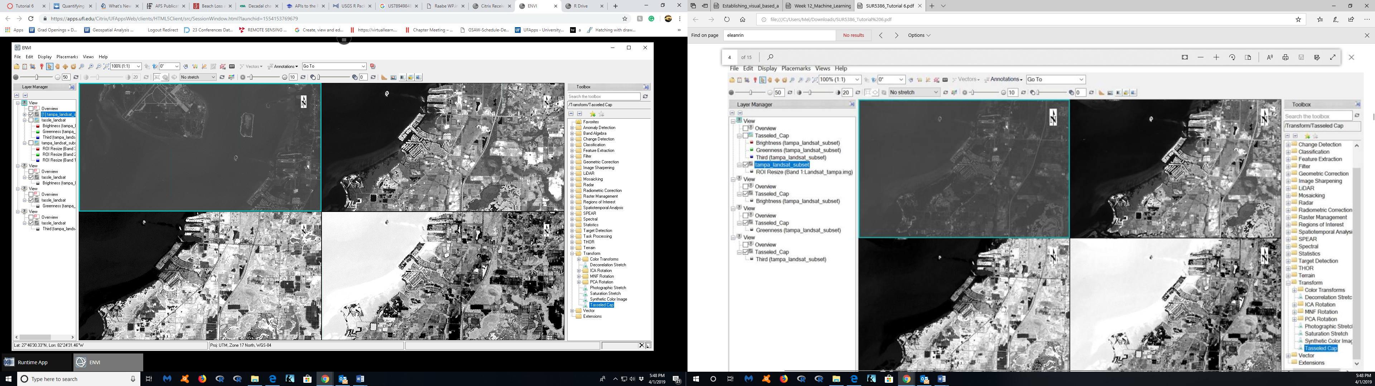

4.i

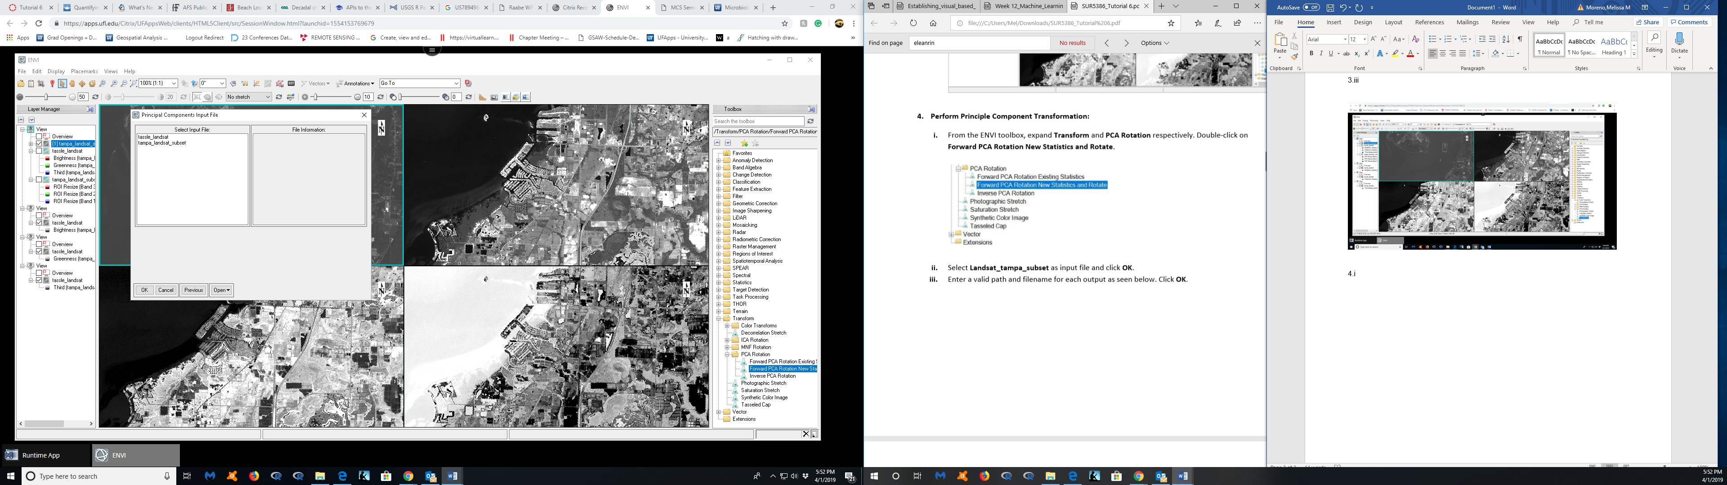

4.ii

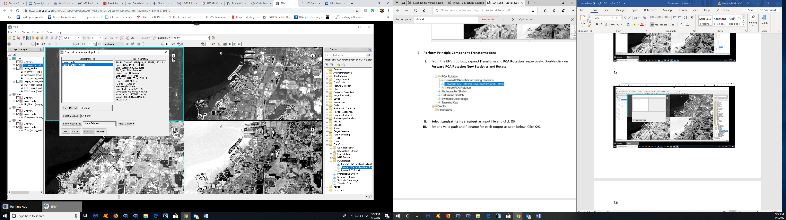

4.iv

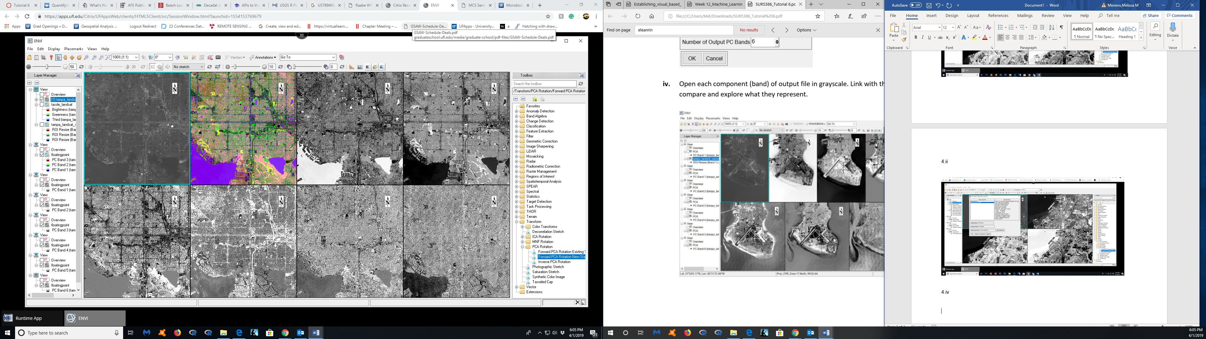

5.i- ii

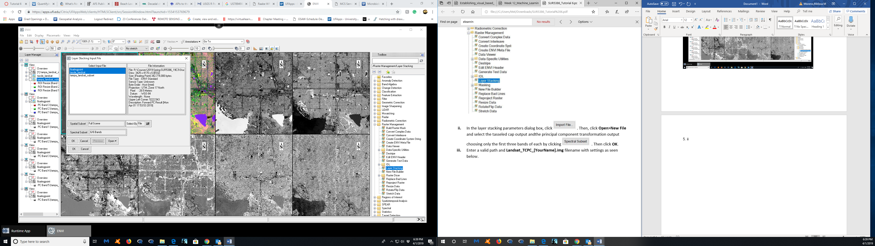

5.iii

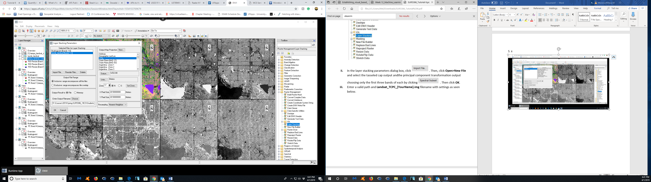

6. ix

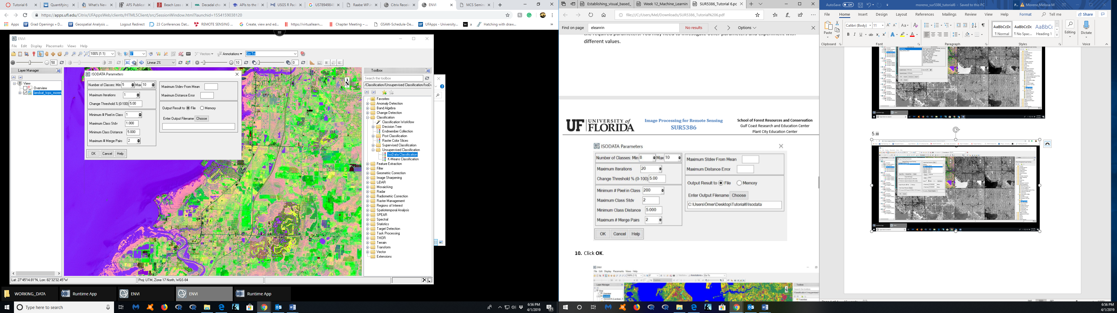

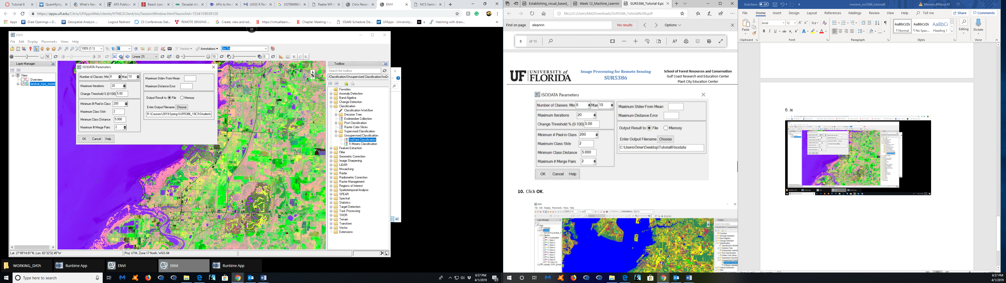

6.x

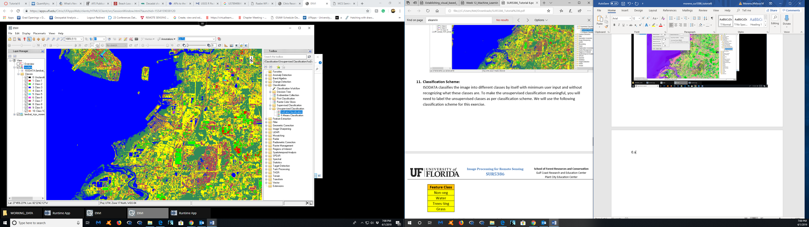

6.xii.i

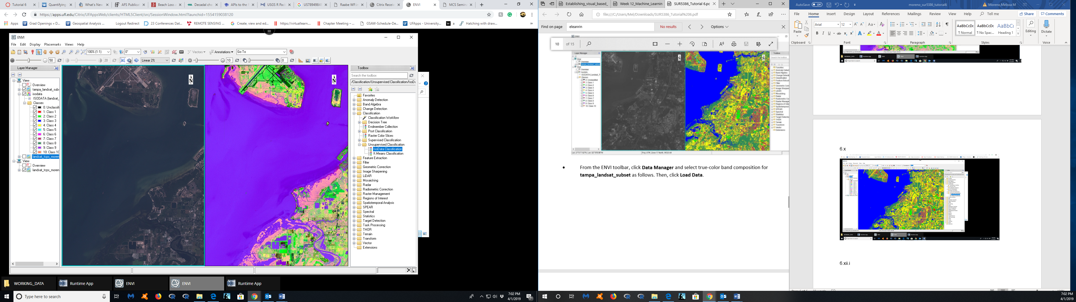

12.ii

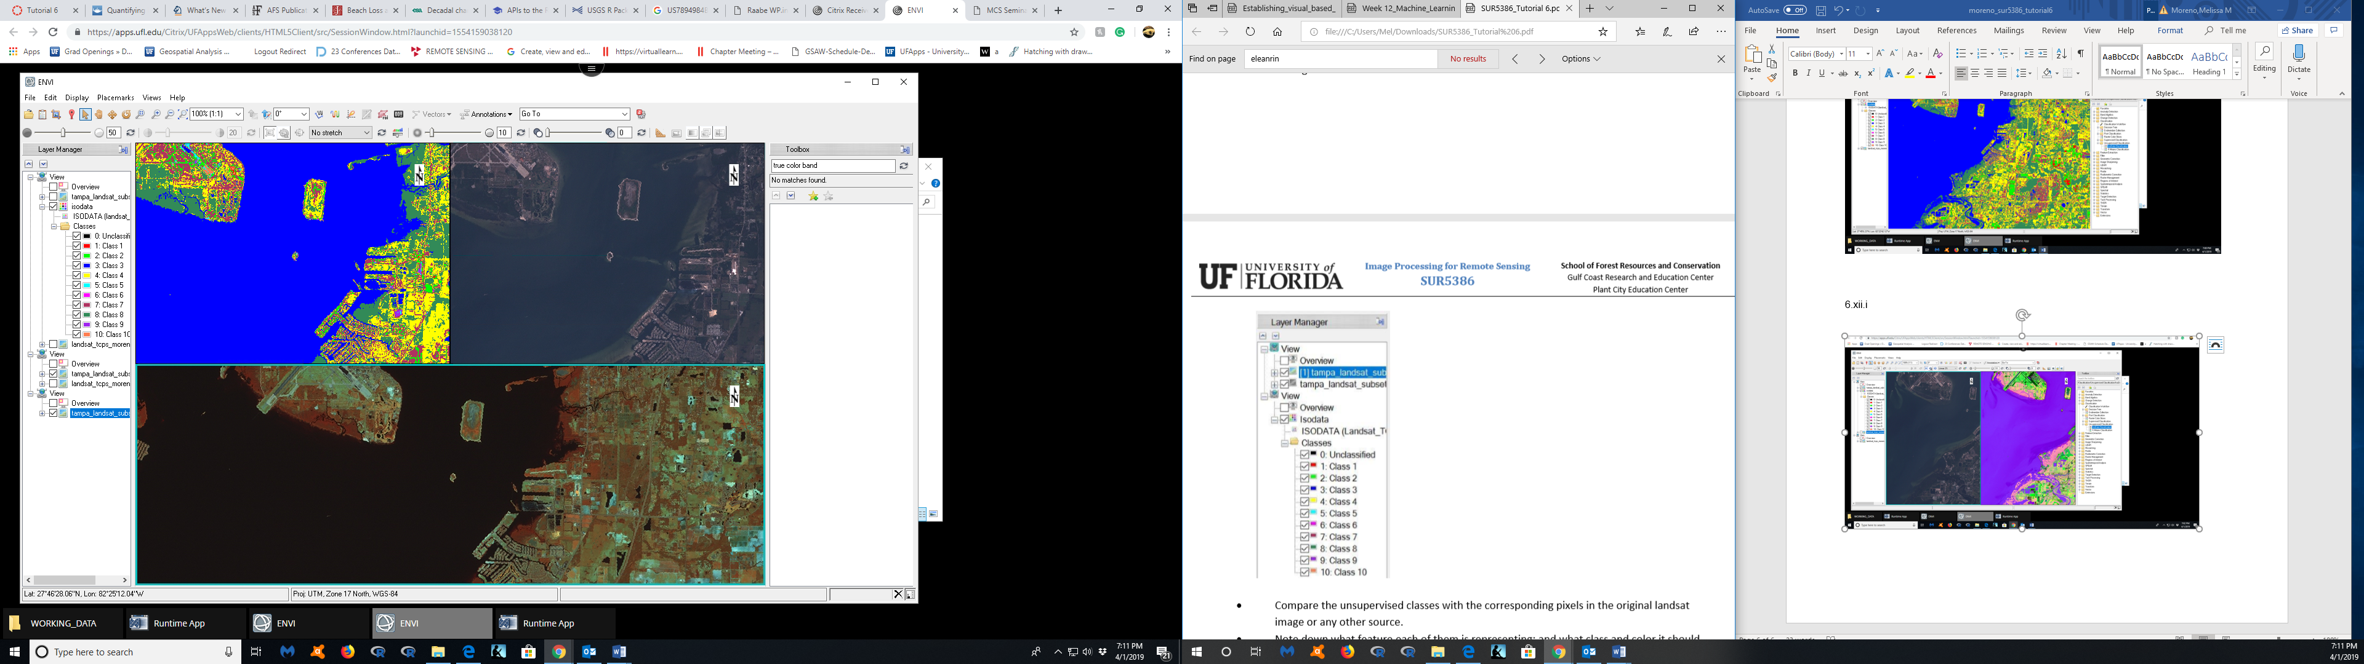

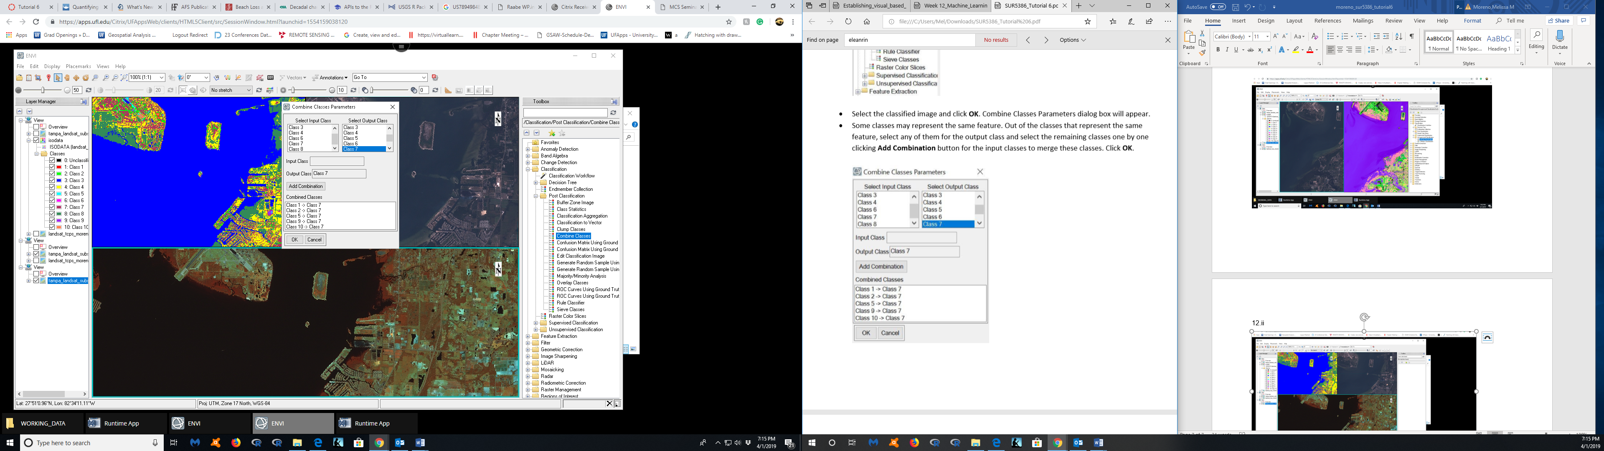

Last Output

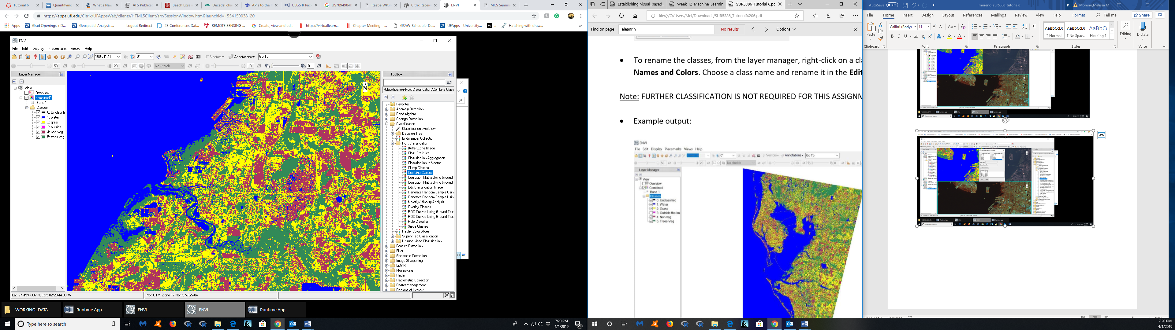

Assignment 6:

1. Perform an unsupervised classification on the image (Landsat_TCPC_[YourName].img) yourself. The number of classes should be 20 or more (instead of the 10 classes instructed earlier). Provide a screen snapshot of the classified image showing class names. Comment on the differences between the results obtained using 10 and 20+ classes.

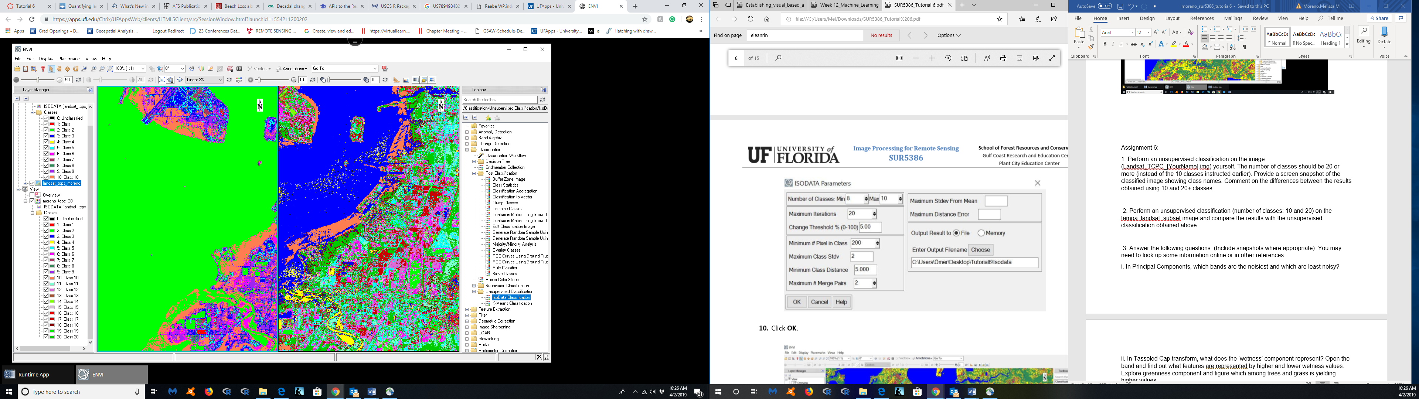

Left classes to 10, right classes to 20

Major differences:

* More classes in the right view, show differences in ocean, and more variation in the land.
* The left image shows just one color for the ocean and much fewer colors for the land.
* Right view took a long time to render.
* Left view took a short time to render.

1. Perform an unsupervised classification (number of classes: 10 and 20) on the tampa_landsat_subset image and compare the results with the unsupervised classification obtained above.

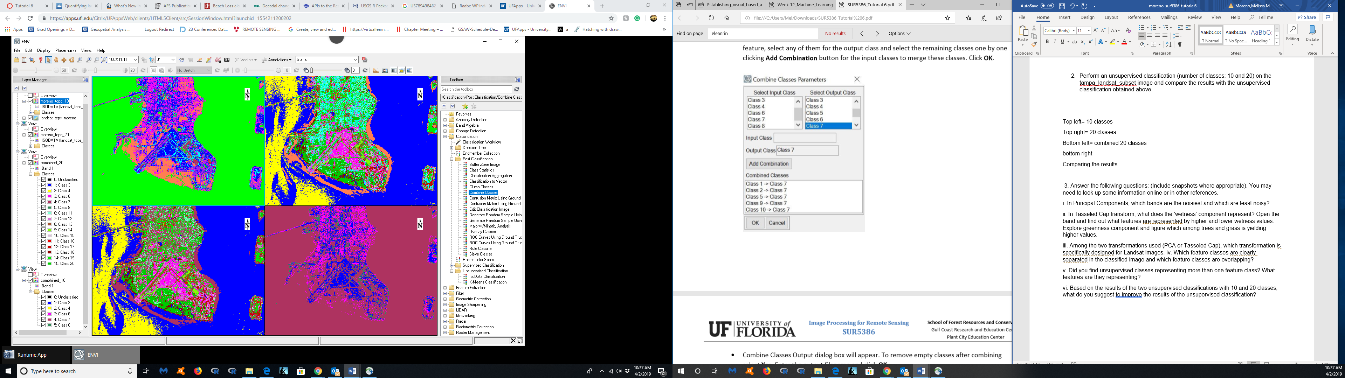

Top left= 10 classes

Top right= 20 classes

Bottom left= combined 20 classes

Bottom right= combined 10 classes

Comparing the results

* Combining classes with such few classes reduces a lot of the color variation we see in other views.
* Having more classes has shows more differences in the land and ocean variations.
* Both views with the 10 classes seems less informative to me, than the view with the 20 classes.

3. Answer the following questions: (Include snapshots where appropriate). You may need to look up some information online or in other references.

i. In Principal Components, which bands are the noisiest and which are least noisy?

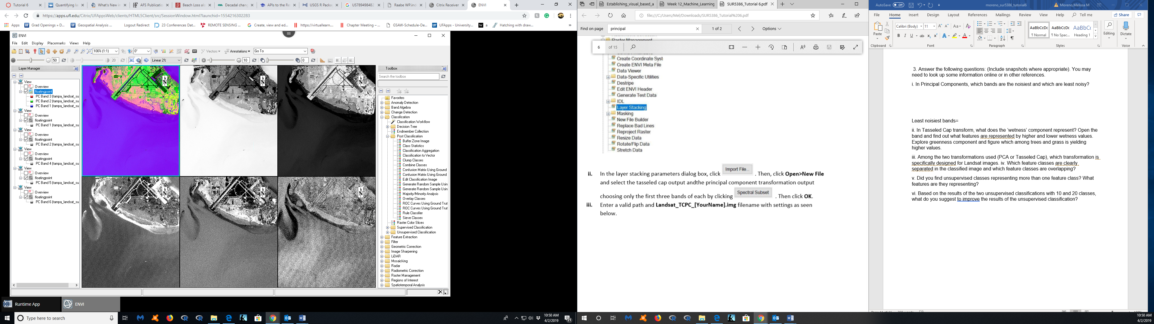

Least noisiest bands= 1,2

Most nosiest bands= 3,5

ii. In Tasseled Cap transform, what does the ‘wetness’ component represent? Open the band and find out what features are represented by higher and lower wetness values. Explore greenness component and figure which among trees and grass is yielding higher values.

iii. Among the two transformations used (PCA or Tasseled Cap), which transformation is specifically designed for Landsat images.

Something very much like the tasseled cap transformation could have arisen from strictly empirical observations. Principal component analysis could have provided the inspiration and guide for specifying the tasseled cap transformations. Principal component analysis creates new variables as weighted sums of the different channel readings. Typically the first few components contain most of the information in the data so that four channels of LANDSAT MSS data or the six channels of the Thematic Mapper data may be reduced to just three principal components. The componenets higher than three are usually treated as being informationless noise.( http://www.sjsu.edu/faculty/watkins/tassel.htm)

The weights used in principal component analysis are determined statistically from the data but it was soon observed that typically the first principal component typically corresponded to roughly equal weights. In other words, the data generally fall along the diagonal when channel values are plotted together. If the weights used in a weighted-sum transformation are equal then the values obtained are proportional to the sum of the channel values and hence correspond to "brightness." (http://www.sjsu.edu/faculty/watkins/tassel.htm)

Principal component analysis is equivalent to transforming the data to a new coordinate system with a new set of orthogonal axes. The tasseled cap transformation also corresponds to a transformation of the data to a new set of orthogonal axes. While the tasseled cap transformation was inspired by the method of principal component analysis combined with generalization from empirical observations the actual details had a more analytical basis.( <http://www.sjsu.edu/faculty/watkins/tassel.htm>)

Is looks like PCA is more ideal for Landsat imagery because typically the first few components are the bands that have the most information, which is how landsat imagery is structured.

iv. Which feature classes are clearly separated in the classified image and which feature classes are overlapping?

I think that the feature classes are clearly separated are water and trees-veg, but some features that overlap are trees-veg and grass.



v. Did you find unsupervised classes representing more than one feature class? What features are they representing?

I found the non-veg representing more than one feature class. I observed that the non-veg was appearing in areas where there could possibly be veg. I think that in that case, there would need to be ground truthing, or using realistic colors in the imagery to determine what you are really looking at. Some features the non-veg could represent are veg, or grass.

vi. Based on the results of the two unsupervised classifications with 10 and 20 classes, what do you suggest to improve the results of the unsupervised classification?

Unsupervised classification clusters pixels in a dataset based on statistics only, without requiring you to define training classes.

ISODATA unsupervised classification starts by calculating class means evenly distributed in the data space, then iteratively clusters the remaining pixels using minimum distance techniques. Each iteration recalculates means and reclassifies pixels with respect to the new means. This process continues until the percentage of pixels that change classes during an iteration is less than the change threshold or the maximum number of iterations is reached. (<https://www.harrisgeospatial.com/docs/Classification.html>)

For ways for this to improve the results of the unsupervised classification could be to reduce the minimum distance between the calculations and techniques to make the end result more accurate.